# CS 255 System Design Document

## UML Diagrams

### UML Use Case Diagram

### UML Activity Diagrams

*

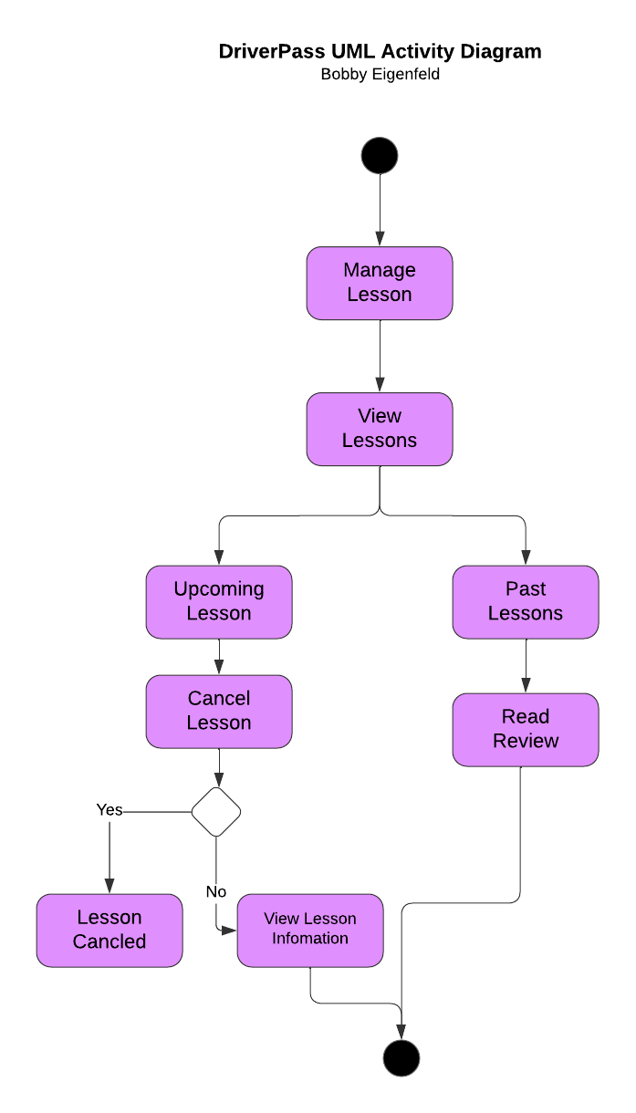

### UML Sequence Diagram

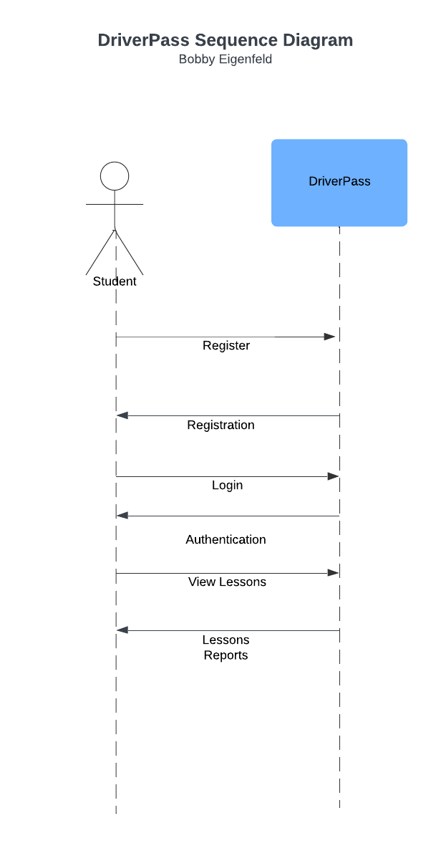

### UML Class Diagram

## Technical Requirements

To design and implement the DriverPass system, several technical requirements must be addressed to ensure efficient and secure operation. The **hardware requirements** include servers capable of hosting the web application with scalable resources to manage varying traffic loads as the business expands. These servers should support virtualization and cloud hosting for flexibility, redundancy, and high availability. Additionally, the system must be compatible with modern web standards, ensuring it functions smoothly on a variety of mobile devices and desktops used by both customers and employees.

On the **software side**, the system will require a robust backend framework to handle business logic and data processing, along with a relational database management system to store customer information, reservations, and transaction records. The front end should be developed using standard web technologies to create a user-friendly, responsive interface. **Security measures** like encryption for data transmission and role-based access control to manage user permissions are essential.

For **infrastructure needs** include a reliable cloud service provider for hosting, databases, and storage, reducing the necessity for in-house infrastructure management. Tools for continuous integration and deployment will be important for automating updates and patches. The system will also require API integration to stay up to date with external systems, such as those used by the DMV. Additionally, robust data backup solutions and monitoring tools will be necessary to ensure the system's security, availability, and data integrity.